What is Data Visualization?

* Ask: What is data visualization?
* No one knows, yet is everywhere
* Examples
  + Your laptop or phone operating software
  + Google search
  + Bar charts and graphs
* Current state of data visdvualization:
  + Data science
  + Information design
  + Visual design
  + Interaction design
  + Front end development

Process and Principles

Research & Research

* Human-centered design (HCR) research process
  + Problem/content: Frame the problem/hypothesis or message
    - Research
    - Explore precedents
  + Ideation: brainstorm solutions
  + Iterative prototyping
    - Low fidelity prototypes: hand-drawn sketches, wireframes
    - High fidelity prototypes: digital renders, motion mock-ups
  + User testing & feedback loops: feedback for iterative design
  + Product deliverable
  + Maintenance, ongoing testing, support and updates

Development

* Stack
  + Back-end
    - Data architecture (i.e. conceptual, diagrams, sketches)
    - Data sourcing (i.e. python, node.js, APIs)
    - Data cleaning (i.e. node.js, python, r)
    - Data storage (i.e. AWS: DynamoDB, PostgreSQL)
    - Data analysis (i.e. Python, R)
    - Data transformations (ETL software, Python, R)
    - Data maintenance (the above for each task)
  + Design
    - Research (i.e. market research, writing, reports)
    - Visual Design (i.e. Illustrator, Sketch)
    - User experience (UX) Design (i.e. Illustrator, Sketch)
    - Motion and Interaction Design (i.e. AfterEffects, Principle)
  + Build; Release
    - Front end-development (HTML/CSS, JavaScript, mapbox/leaflet, node.js, JS libraries such as d3.js, chart.js, three.js)
    - UX Engineering (HTML/CSS, JavaScript, JS frameworks such as Vue, React, Angular)
    - Production-level development (HTML/CSS, JavaScript, shadow DOM, own libraries, etc.)
  + Process can take 3 months for one release

Affordances

* Spatial: How do I learn to navigate digital abstractions as artifacts?
* Encyclopedic: How is information organized, accessed, shaped, made transparent?
* Procedural: What does it do?
* Participatory: What can I do?

My additions:

* Data democratization

An affordance of data visualizations is that data can be more accessible, can be cleaner, more transparent, and updated more frequently or in real-time

* + Fidelity/Uncertainty
  + Integrity
  + Performance
* Storytelling

An affordance of data visualizations is that data can be crafted in beautiful and interesting ways that are relevant to the viewer and targeted audiences

* + How simple is the story?
  + How is the viewer introduced to key concepts?
  + How is the viewer led or guided through the story?
  + How is the interactor engaging in dialogue or reciprocal exchange?
* Design

An affordance of data visualizations is that there are many visual abstractions available for expression.

* + Why were aesthetic choices made?
  + Did design support or hinder data message?
  + Did design support or hinder story?
* Motion & Interactivity

An affordance of data visualizations is that interactivity can engage interactors in dialogue or reciprocal exchange

* + Is motion or interactivity meaningful to the data message, storytelling, and/or support primary design choices?
  + Does motion or interactivity create a dynamic experience for the viewer?
  + Do motion or interactive artifacts create opportunities for dialogue or reciprocal exchange with the data?

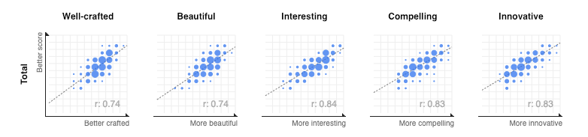

Source: https://medium.com/@jcukier/judging-the-iib-awards-865851ff0ce8

JFI Visualizations (Precedents and Current State)

UBI

Precedents

* Clustering

Current State

ISA

Precedents

Current State

Algorithmic Fairness

Precedents

* Nicky case

Current State